Name: Richard (Trey) Mallory
Nationality: Bermudian
Education: Bachelor’s Degree in Healthful Living and Fitness Education, University of North Carolina Wilmington (UNCW)
Athletic Background: NCAA Division I Tennis Player
Representation: Bermuda National Davis Cup Team

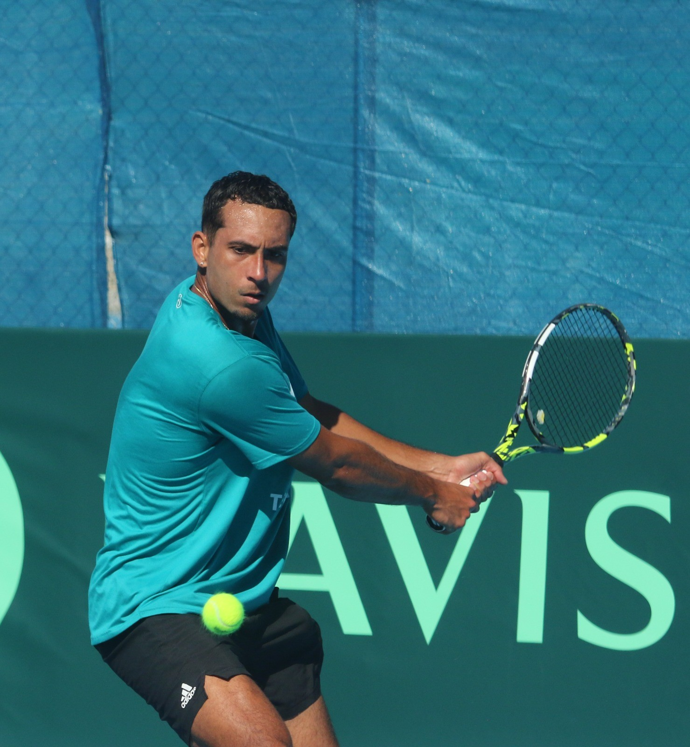

Contact Information
Email: treymallory2002@gmail.com
Phone: 786-721-9729
Location: Miami, Florida

Professional Statement:
I am a recent college graduate from the University of North Carolina Wilmington, where I earned a bachelor’s degree in Healthful Living and Fitness Education and competed as a Division I student-athlete on the men’s tennis team. Over the past six years, I have proudly represented Bermuda in the Davis Cup, competing against some of the top players in the region and contributing to Bermuda’s historic promotion to Group II for the first time in 2025.
Building on this momentum, I am dedicating the next two years to training and competing full-time on the professional tennis circuit. My goal is to represent Bermuda on the global stage, earn international ranking points, and continue developing as an elite athlete.
To support this journey, I am actively seeking sponsorship and partnerships that will allow me to focus on high-performance training, international travel, and tournament competition. Financial assistance will directly contribute to coaching, equipment, travel, and tournament entry expenses — all critical elements in pursuing a successful professional tennis career.
I am committed to excellence, professionalism, and representing my sponsors and country with integrity both on and off the court.

General Weekly Training Schedule:
On-Court Tennis Training 5–6 sessions/week Technical drills, point construction, match play
Strength & Conditioning 3–4 sessions/week Strength, agility, mobility, and cardio
Personal Training / Fitness 2 sessions/week Core, balance, and explosive movement
Mental Skills / Strategy 1–2 sessions/week Visualization, match analysis, mindfulness
Recovery & Flexibility Daily Stretching, ice baths, physiotherapy, yoga
Competition Schedule (Tunisia Men’s Circuit):
ITF M15 Tunisia #1 Monastir (May/June) Season debut – assess readiness
ITF M15 Tunisia #2 Monastir (May/June) Refine tactical play and endurance
ITF M15 Tunisia #3 Monastir (May/June) Peak performance and ranking push
Expected Outcomes:
- Compete in three ITF Men’s tournaments with full professional preparation.
- Achieve measurable ranking points or improved competitive performance.
- Establish consistent relationships with a coach and trainer for long-term development.
- Build visibility with sponsors and grow professional tennis experience.

